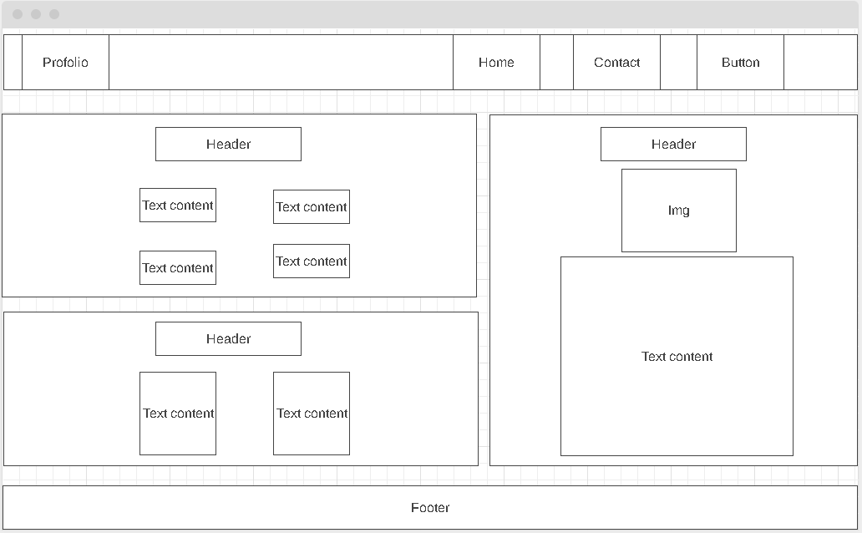

Font-Size: 2vh

Font-Size: 2vh

Font-Size: 2vh

Font-Size: 2.2vh

Font-Size: 2.2vh

Background: black

Light Mode Background: Grey